 Assisted Practice  EMP ID :2587303

NAME:R.HIMABINDU

1. You are given a project to explain the basics of Cucumber setup (Maven, Extent Reports, and Cucumber Eclipse Plugin).

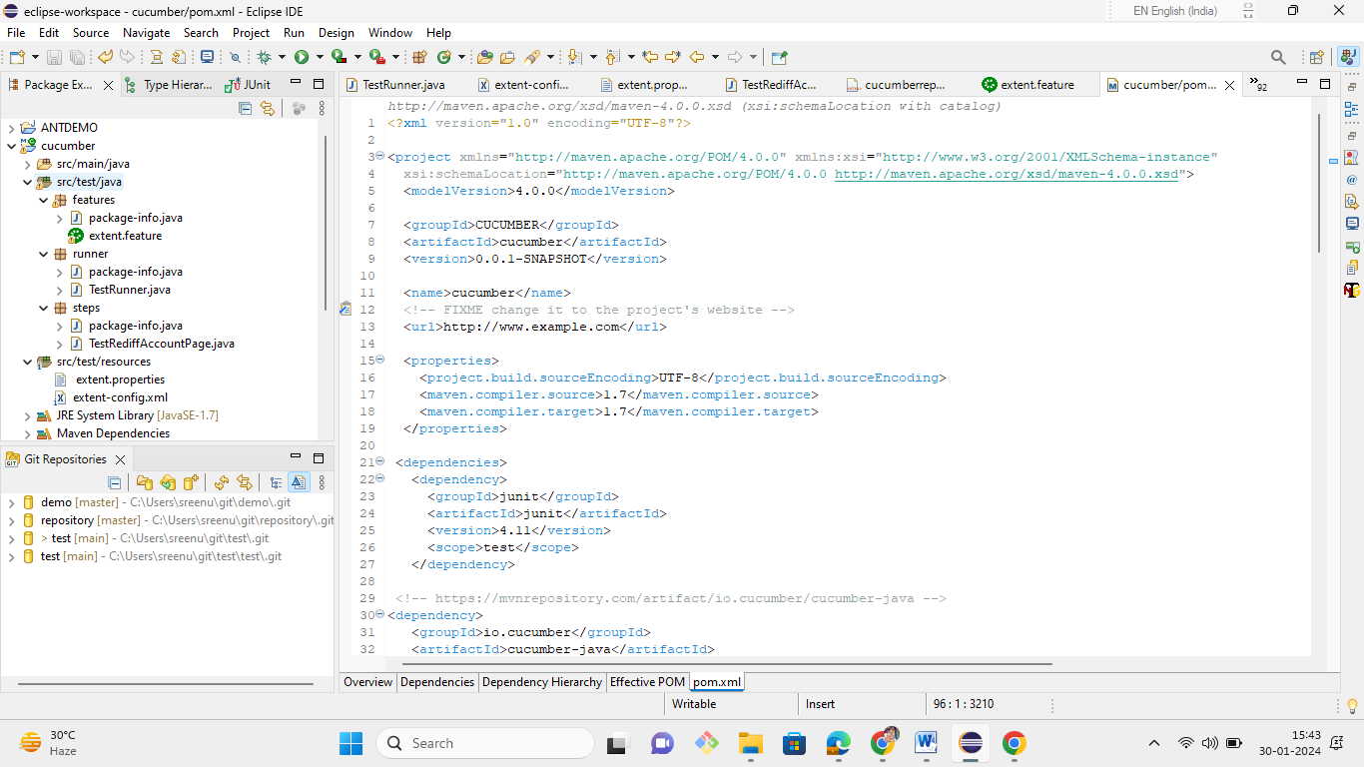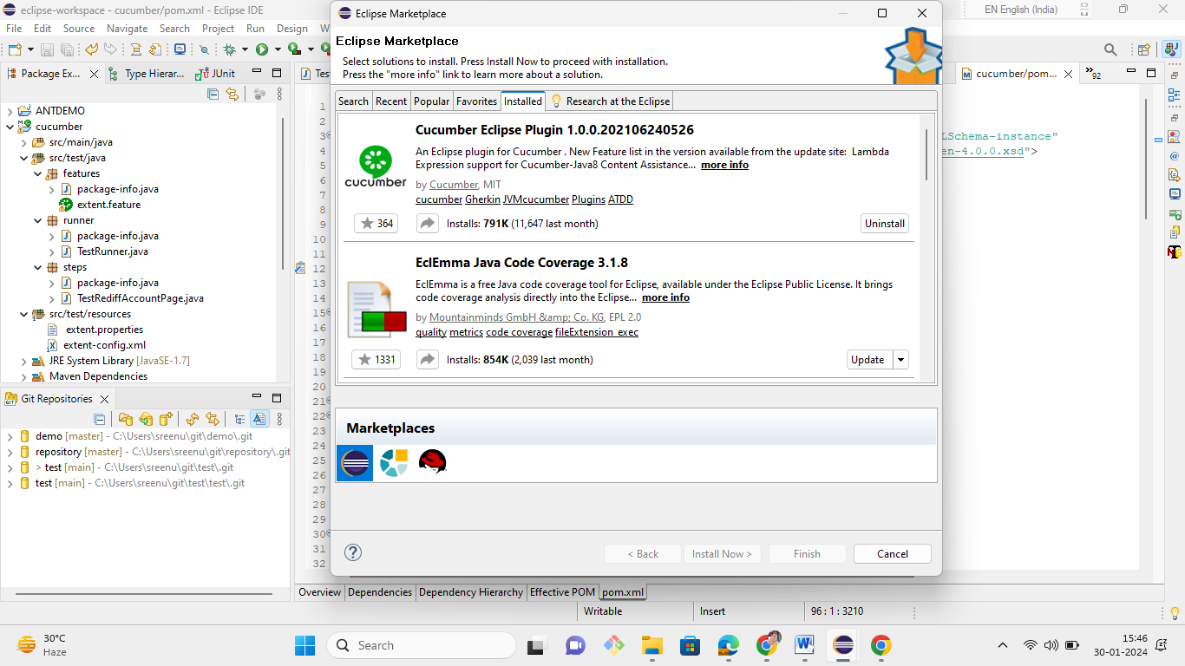

1. You are given a project to define the functions of various Gherkin keywords.

The following are the keywords used in Gherkin:

* **Feature**: This gives information on the high-level business functionality and the purpose of application under test. Everybody should be able to understand the intent of feature file by reading the first feature step.

Feature: LogIn Action Test

Description: This feature will test a LogIn and LogOut functionality

* **Scenario**: Basically, a scenario represents a particular functionality which is under test. By seeing the scenario, user should be able to understand the intent behind the scenario and test.

Scenario: Successful Login with Valid Credentials

Given User is on Home Page

When User Navigate to LogIn Page

And User enters UserName and Password

Then Message displayed Login Successfully

1. You are given a project to demonstrate Gherkin: Given, When, Then, and Background Steps

Each scenario should follow **given**, **when**, and **then** format.

* Given: n Specifies the preconditions. It is basically a known state.
* When: This is used when some action is to be performed. Then: The expected outcome or result should be placed here. For Instance, verify if the login and page navigation is successful.
* Background: Whenever any step is required to be performed in each scenario, then those steps are to be placed in the Background. For Instance, If user needs to clear the database before each scenario, then those steps can be put in the background.
* And: Used to combine two or more actions of the same type.
* But: Signifies logical OR condition between any two statements. OR can be used in conjunction with GIVEN, WHEN ,and THEN statement.

|  |
| --- |
| *Feature: Add to Cart*  *This feature will test functionality of adding different products to the User basket from different flow*  *Background: User is Logged In*  *Scenario: Search a product and add the first result/product to the User basket*  *Given User searched for Lenovo Laptop*  *When Add the first laptop that appears in the search result to the basket*  *Then User basket should display with 1 item* |

1. You are given a project to explain Step Arguments in Gherkin.

* In some cases, you might want to pass more data to a step that fits on a single line. For this purpose, Gherkin has Docstrings and Data tables.

**Step 5.4.2:** Docstrings

* If you need to specify information in a scenario that won't fit on a single line, you can use Docstrings.
* A Docstring follows a step. It starts and ends with three double quotes, like this:

|  |
| --- |
| When I ask to reset my password  Then I should receive an email with:  """  Dear bozo,  Please click this link to reset your password  """ |

**Step 5.4.3:** Data Tables

* Data Tables are handy for passing a list of values to a step definition

|  |
| --- |
| | name |email | twitter |  | Aslak | aslak@cucumber.io | @aslak_hellesoy |  | Julien | julien@cucumber.io | @jbpros |  | Matt | matt@cucumber.io | @mattwynne | |

* Just like Docstrings, Data Tables will be passed to the step definition as the last argument.

1. You are given a project to use comments and tags in a Cucumber scenario.

**Step 5.5.1:** Gherkin comments with example.

* Comment is basically a piece of code meant for documentation purposes and not for execution.
* Feature file: In case of a feature file, we just need to put # before beginning your comment.

**Example:**

|  |
| --- |
| Feature: annotation  #This is how background can be used to eliminate duplicate steps  Background:  User navigates to Facebook  Given I am on Facebook login page |

* Step definition file: If you are using Java as a platform then mark your comments with //.

**Example:**

|  |
| --- |
| //scroll to the bottom of the page  ((JavascriptExecutor) driver).executeScript("window.scrollTo(0, document.body.scrollHeight)"); |

**Step 5.5.2:** Gherkin tags with example.

* if we have many scenarios in a feature file, to put them under a single umbrella, we use tags to generate reports for specific scenarios under the same tag.
* Tags are defined in our runner class like this:

|  |
| --- |
| @RunWith(Cucumber.class)  @CucumberOptions{  format= {"Pretty" ,"json:target/output.json", "html:targer/html"},  feature={"src/functional-test/resources"},  tags={"@tag", "@tag1"} } |

* When we define multiple tags in runner class in below form, it will be defined with the use of logical operator:
  + tags = {“@tag”, “@tag1”}: means AND condition. It says that scenarios matching both these tags need to be executed.
  + tags = {“@tag1, @tag2”}: means OR condition. It says that scenarios matching any of this tag need to be executed.

1. You are given a project to demonstrate the execution of a step definition file. 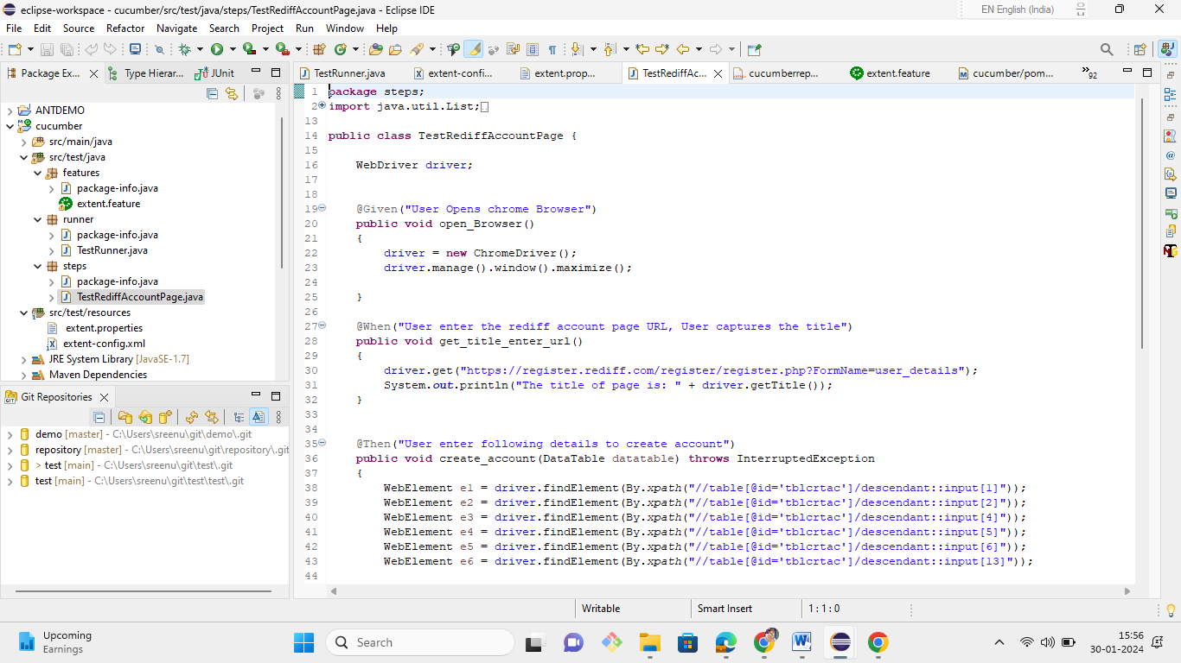

7. You are given a project to demonstrate how Before and After hooks are used in a scenario.

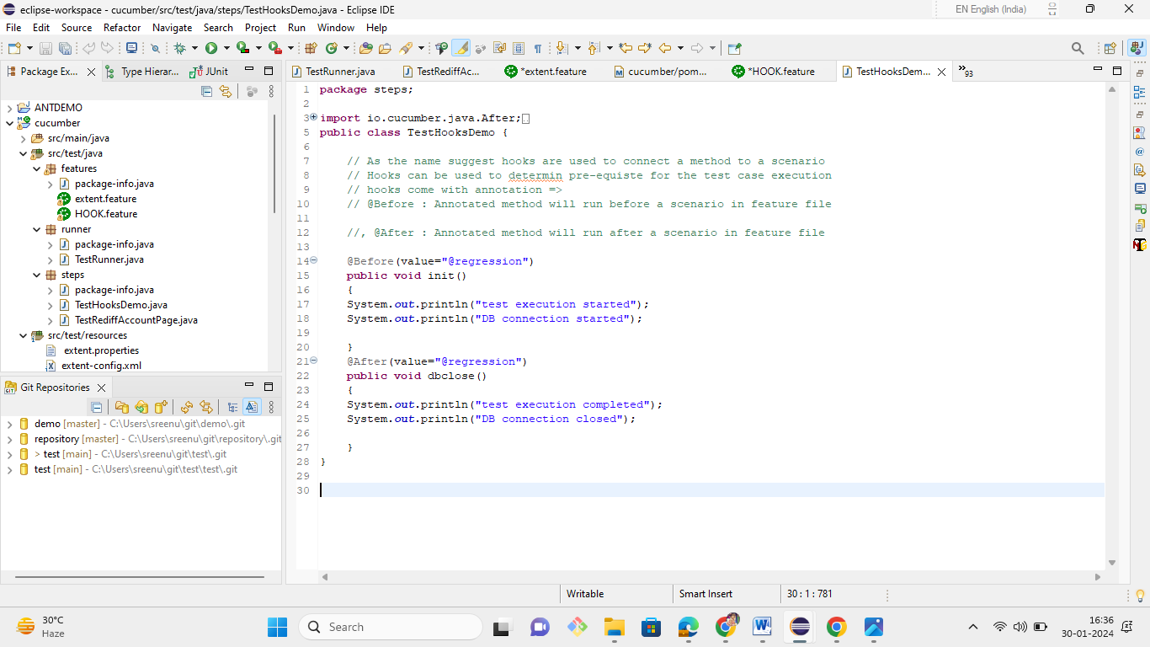

8.You are given a project to demonstrate a tagged scenario.



9. You are given a project to demonstrate how to execute multiple scenarios.

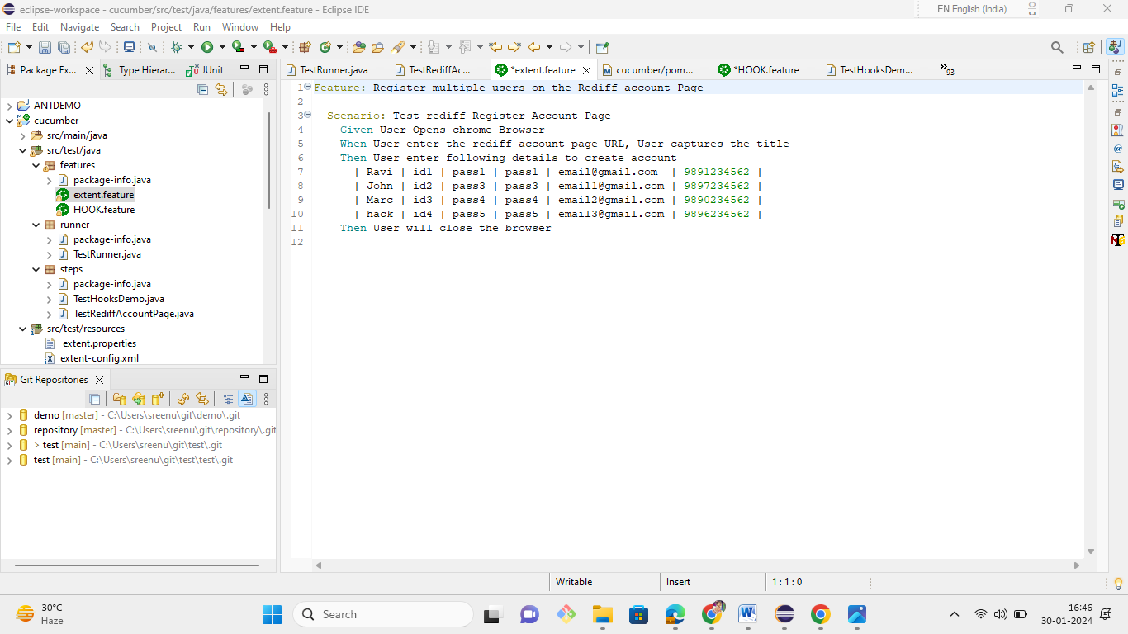

10. You are given a project to demonstrate how to use tagged hooks. 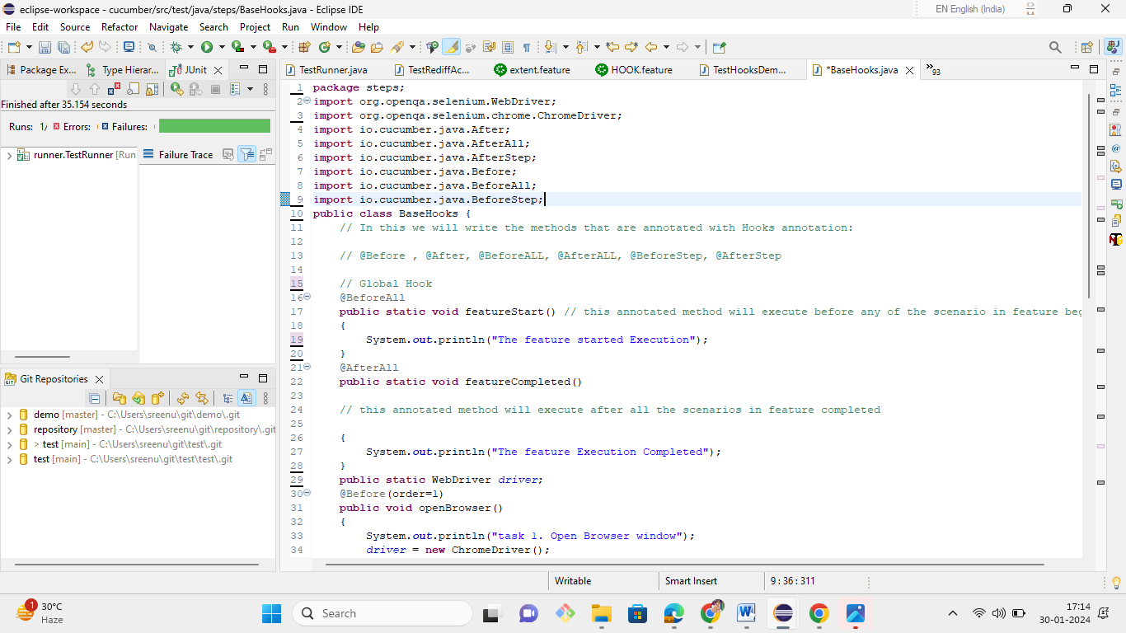

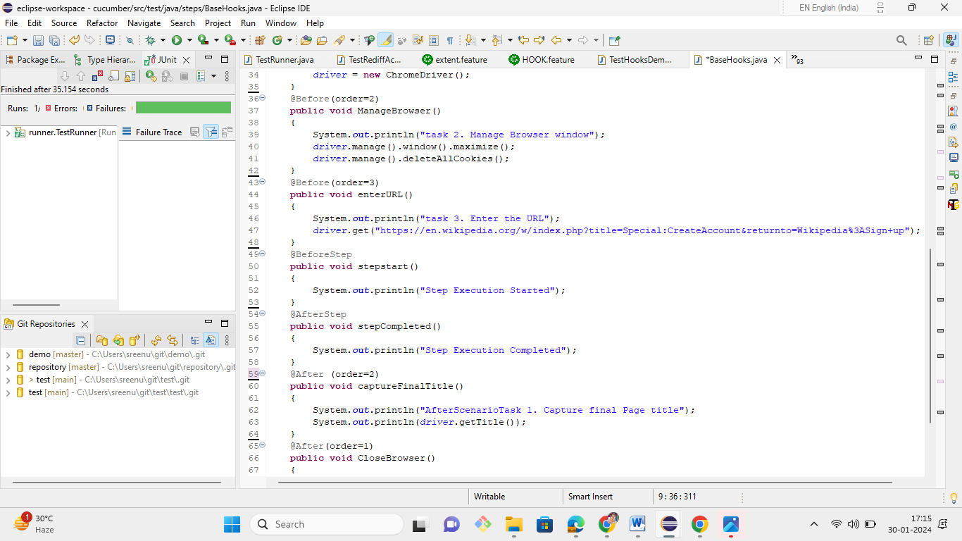

11. You are given a project to demonstrate the use of Logical AND/OR in a scenario.

## Logical ANDing and ORing Tags

## There would be situations when you want to run all the scenarios related to two or more features. Cucumber tagging gives us the capability to choose what we want with the help of *ANDing* and *ORing*.

|  |
| --- |
| #Example of Non-Optional Capture Group  @nonoptional @smoke @basicsearch  Scenario: Keyword Search bu different users  When I fill "search textbox" with "dress"  Then I click "search button"  Then I follow "TOP SELLERS" **link**  Then She follow "TOP SELLERS" **link**  Then He follow "TOP SELLERS" **link**  Then **User** follow "TOP SELLERS" **link**    #String transformation example  @smoke @datetest @advancesearch  Scenario: Enter date **in** different format  Given The date is 2012-03-01T06:54:12 |

* **ANDing:** When we want to run the Scenarios with all the required Tags.

For example: when you want to execute scenarios tagged with @basicsearch and @smoke. Use below code in your Cucumber runner class:

|  |
| --- |
| @RunWith(Cucumber.class)  @CucumberOptions(  plugin = {"pretty", "html:target/cucumber"},  features = {"src/test/resources/features"},  glue={"com.pb.cucumberdemo.stepdefinitions"},  tags = {"@basicsearch", "@smoke"},  ) |

* **ORing:** When we want to run the Scenarios with either of the mentioned Tags. For example, when you want to execute the scenario tagged with @basicsearch or @advancedsearch.

|  |
| --- |
| @CucumberOptions(  plugin = {"pretty", "html:target/cucumber"},  features = {"src/test/resources/features"},  glue={"com.pb.cucumberdemo.stepdefinitions"},  tags = {"@basicsearch, @advancesearch"},  ) |

12. You are given a project to demonstrate how Cucumber data tables are used.

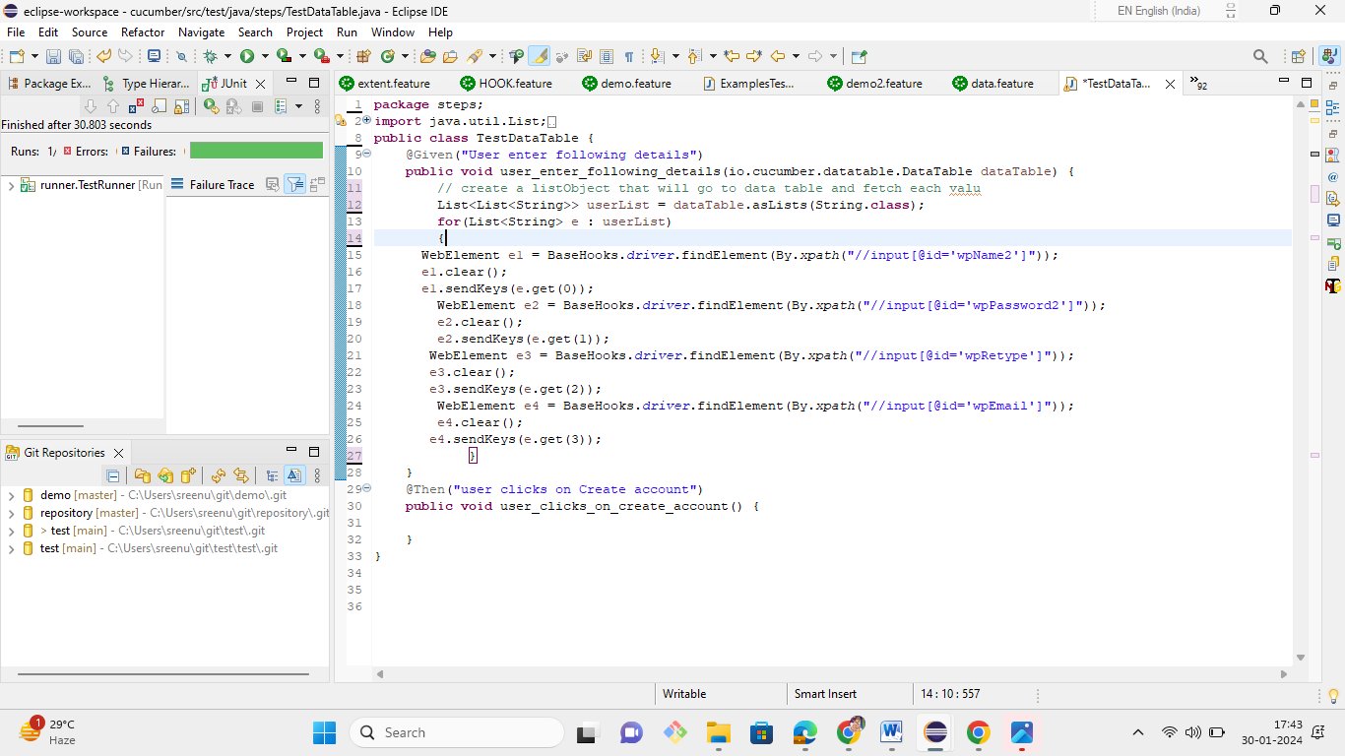

13. You are given a project to demonstrate Cucumber Integration with Extent Report.

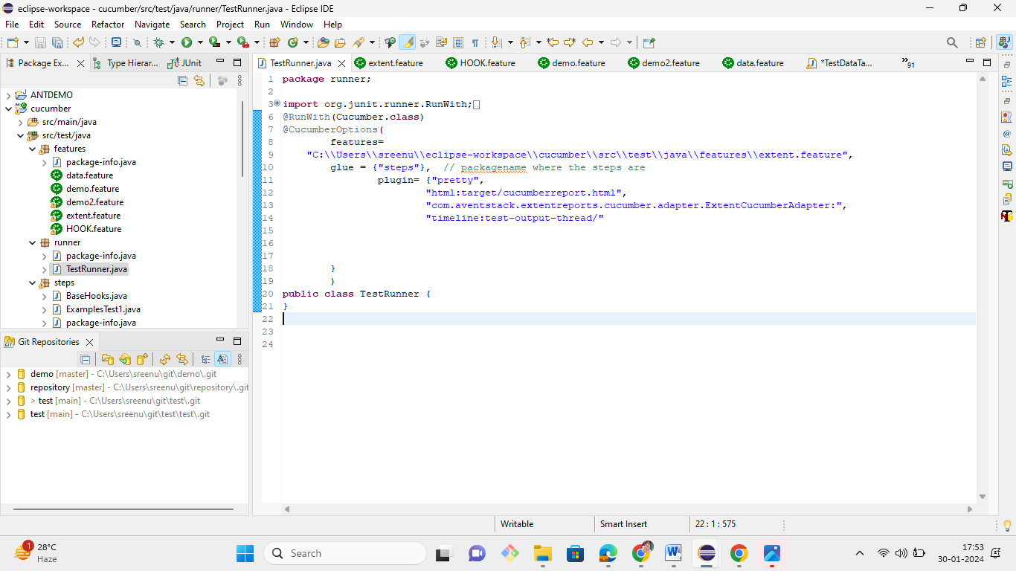

14. You are given a project to demonstrate complete Cucumber Test Execution with Maven on a local machine.

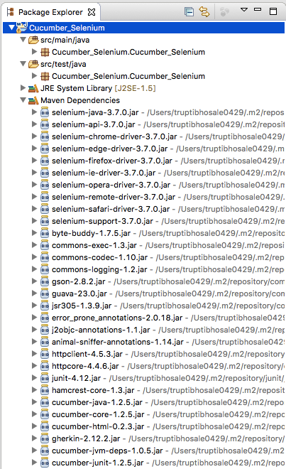

15. You are given a project to demonstrate how to build (execute) a Jenkins job.

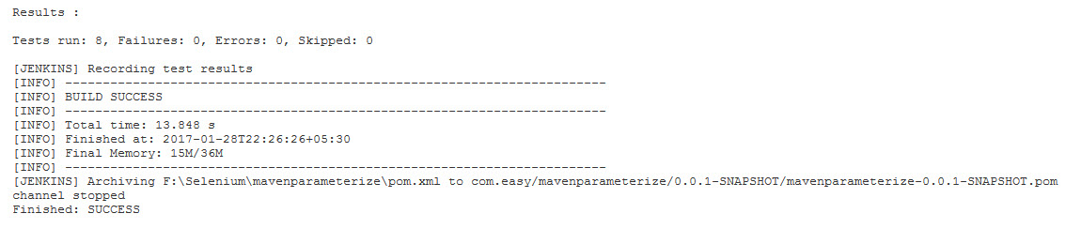

16. You are given a project to demonstrate integration of Jenkins with extent reports.

